CS2130 Final Exam

|  |  |  |  |  |  |  |  |  |
| --- | --- | --- | --- | --- | --- | --- | --- | --- |
| aTeX: p | aTeX: q | aTeX: r | aTeX: -q | (aTeX: -q\wedge r) | aTeX: p\:\vee\left(-q\:\wedge r\right) | aTeX: p\vee-q | aTeX: p\vee r | aTeX: \left(p\:\vee-q\right)\:\wedge\:\left(q\:\vee\:r\right) |
| **T** | **T** | **T** | **F** | **F** | **T** | **T** | **T** | **T** |
| **T** | **T** | **F** | **F** | **F** | **T** | **T** | **T** | **T** |
| **T** | **F** | **T** | **T** | **T** | **T** | **T** | **T** | **T** |
| **T** | **F** | **F** | **T** | **F** | **T** | **T** | **T** | **T** |
| **F** | **T** | **T** | **F** | **F** | **F** | **F** | **T** | **F** |
| **F** | **T** | **F** | **F** | **F** | **F** | **F** | **F** | **F** |
| **F** | **F** | **T** | **T** | **T** | **T** | **T** | **T** | **T** |
| **F** | **F** | **F** | **T** | **F** | **F** | **T** | **F** | **F** |

**Question 4:**

Sorry if this looks strange, I made it in Canvas first then pasted it over.

**Question 6:**

a.

**CD**

|  |  |  |  |  |
| --- | --- | --- | --- | --- |
|  | 00 | 01 | 11 | 00 |
| 00 |  | 1 |  |  |
| 01 |  | 1 |  |  |
| **AB**  10 | 1 | 1 | 1 | 1 |
| 11 | 1 | 1 |  |  |

b. AC’ + A’C’D + ABC

**Question 11:**

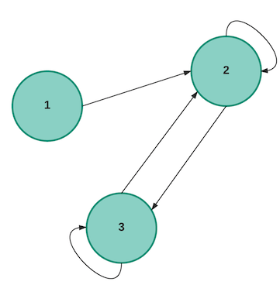

**Question 14:**

*End state s5, start state s0.*

